# ArcCatalog 10.4 ANZLIC Profile Installation guide

## Introduction

The ANZLIC metadata custom tool for ArcCatalog 10.4 will give users the ability to enter metadata for feature classes and feature datasets to meet the ANZLIC metadata specifications.

The minimum software requirement is **ArcGIS for Desktop 10.4**.

Steps:

* Install the ANZLIC custom metadata editor.
* Configure ArcCatalog to utilise the ANZLIC metadata profile.
* Configure the Settings XML file.
* Configure Code List and Default value XML files.

## Step 1: Install the ANZLIC custom metadata editor

1. Open the **ANZLIC_10.4_Deployment.zip** file and extract the contents to a location on your computer.
2. Navigate to the ANZLIC installation folder and double click on the setup.exe
3. Follow the installation instructions
4. In the first screen click **Next** to begin the installation

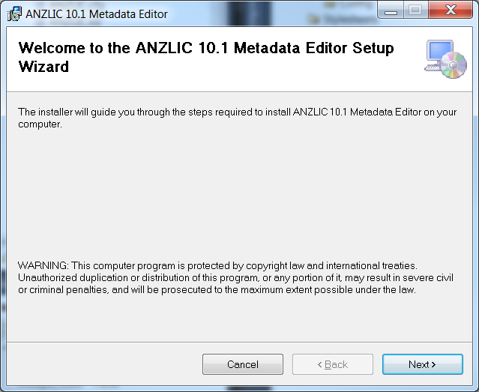

1. Select the install location and this ***must be the same*** as the **ArcGIS Desktop** installation location. Click **Next** to continue.

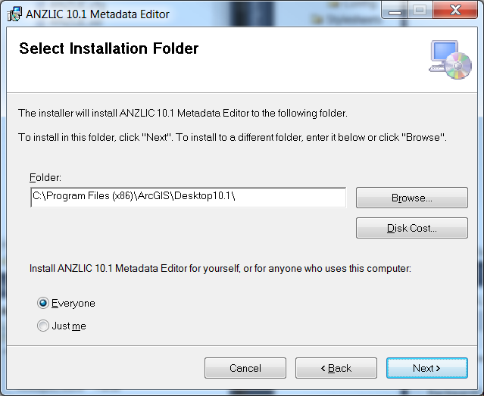

Note: The default folder settings is for a Windows 7/10 64 bit PC, This will be different if you are using a 32 bit PC. (C:\Program Files\ArcGIS\Desktop10.4).

Please update the ANZLIC_Settings.XML with the correct path.

1. Click the Next button to confirm the installation process.

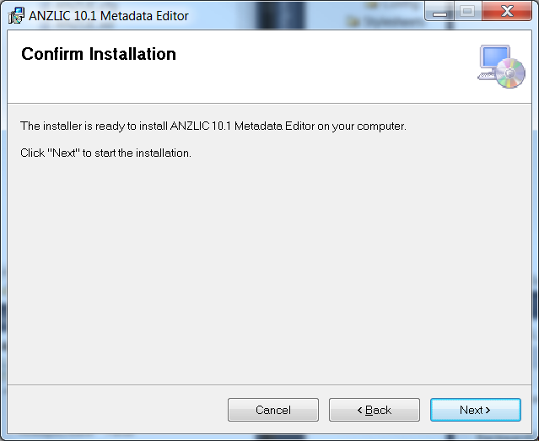

1. Wait for the process to complete.

Note: this can take a few seconds to start.

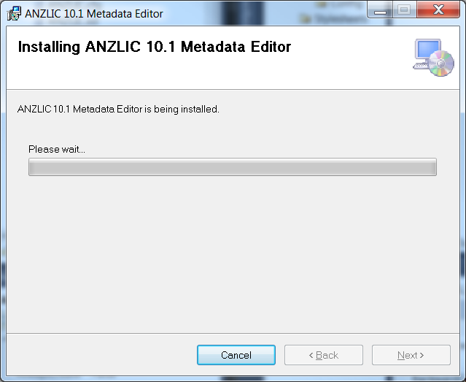

1. Click **Close** to complete the installation.

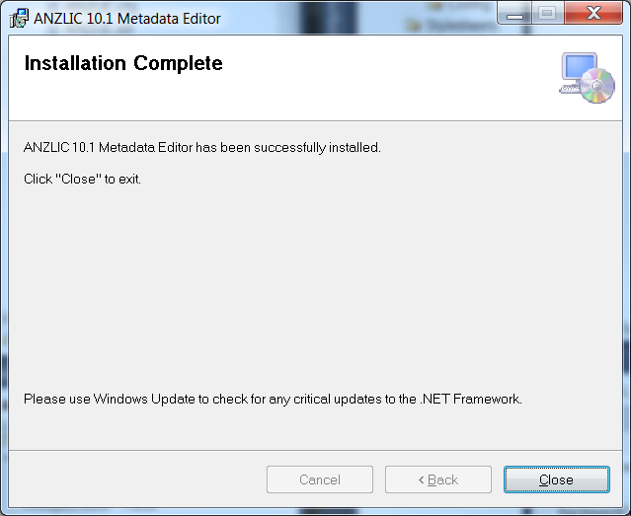

## Step 2: Configure ArcCatalog to utilise the ANZLIC metadata profile

1. Open ArcCatalog
2. Click the Customize Menu item and click ArcCatalog options

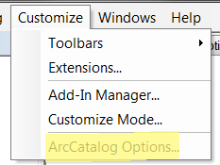

1. On the Metadata tab click on the Metadata Style Dropdown and select ANZLIC and Click OK to apply this setting and Close the window.

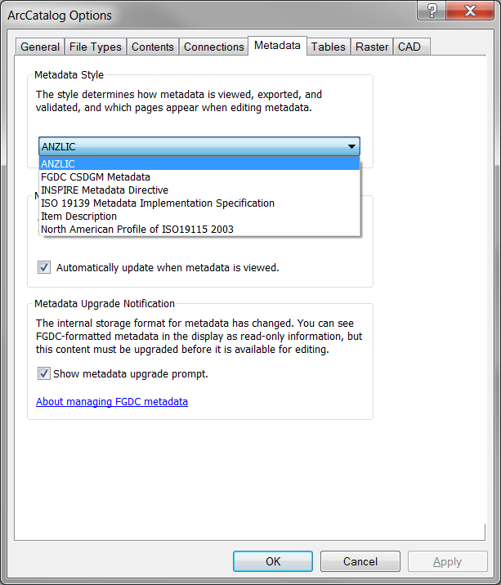

1. Navigate to a Feature Class and select the Feature Class
2. Click on the Description Tab in ArcCatalog
3. Click on the Edit Button  to Open the ANZLIC metadata Editor.

## Step 3: Configure Settings File

The Settings file sets the locations for the defaults values file and the code list XML files. This is for users who want to configure the code list and defaults file locations to a centralised location.

1. Open C:\Program Files (x86)\ArcGIS\Desktop10.4\bin\ANZLIC_Settings \ANZLIC_Settings.XML
2. Change the paths of the required item to point to a new location

<Defaults Value= "\\<HOST>\<Folder>\ANZLIC_Settings\ANZLIC_Defaults.xml"></Defaults>

<DistributionPickList Value="\\<HOST>\<Folder>\\ANZLIC_Codelists_Distribution.xml"> </DistributionPickList>

<KeywordsPickList Value="\\<HOST>\<Folder>\ANZLIC_Codelists_searchThemes.xml"></KeywordsPickList>

<OrganisationPickList Value="\\<HOST>\<Folder>\ANZLICXmlData\ANZLIC_Codelists_Organisations.xml">

</OrganisationPickList>

<PositionsPickList Value="\\<HOST>\<Folder>\ANZLIC_Codelists_Positions.xml"></PositionsPickList>

Note: Remember to move the files to the new location and set the correct security access.

## Step 4: Configure Code List and Default values in the configuration XML files

### Default Values

1. To edit the Default value navigate to the installation location e.g. C:\Program Files (x86)\ArcGIS\Desktop10.4\**bin**\ANZLIC_Defaults.xml
2. Open the ANZLIC_Defaults.xml file.
3. Edit the Value Tag using one of the Values in the Comments Tag e.g. Value 002 to set the Default to Restricted for the Security Classification Element.

<Element>

<Name>MD_ClassificationCode</Name>

<Value>002</Value>

<Interface>MetaData|Constraints|Security Constraints|Classification</Interface>

<Comments>000 Empty|001 Unclassified|002 Restricted|003 Confidential|004 Secret|005 Top Secret</Comments>

</Element>

Note: the Interface Tag indicates the location of the Element where the Default will be applied.

Adding element to this file will not set additional defaults because customisation is required from within the code.

### Code List Values

1. To edit the Code List values, navigate to the installation location e.g. C:\Program Files (x86)\ArcGIS\Desktop10.4\**Metadata**\ANZLIC_CodeLists
2. Edit Code List
   1. Open the Code List xml file e.g. ANZLIC_Codelists_searchThemes.xml
   2. Add or Edit the item in the code tag and save the file
   3. The text value is the value="" tag which is stored in the metadata element and the text between the >nnn< represents the description displayed in the list box.

|  |
| --- |
| <code value="AGRICULTURE">AGRICULTURE non-specific</code> |

## Mandatory Elements

In previous versions the word Mandatory was displayed in a couple locations to give the user a visual cue of required fields.

From the 10.1 version, the mandatory text elements are shaded with a light red colour to indicate that it is mandatory. When a value is added and the text box loses focus the background colour will return to the default white.

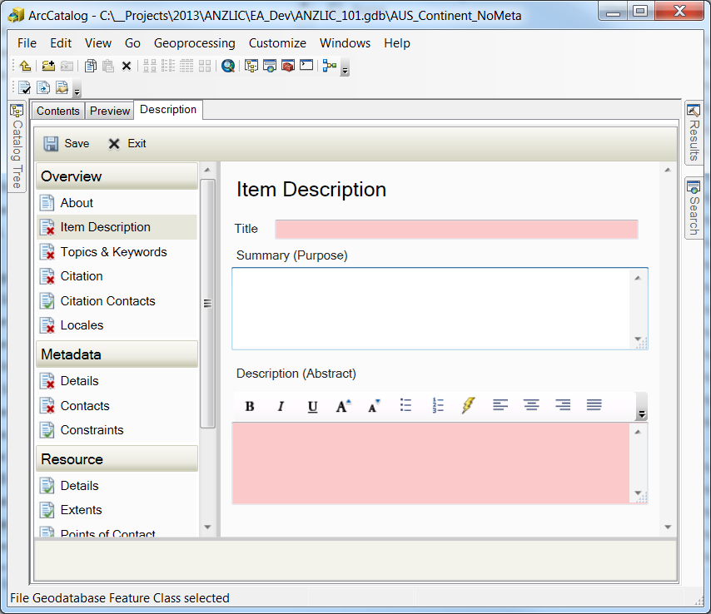

Figure 1: ArcCatalog Validation

Additional validation is handled in the left pane of the ArcCatalog Window which shows a red x next to elements where mandatory elements have no values.

This gives the user a visual cue of where mandatory elements are located. It is also useful for elements that do not have the ability to change its back ground to red like date elements.